SQL to MongoDB Mapping

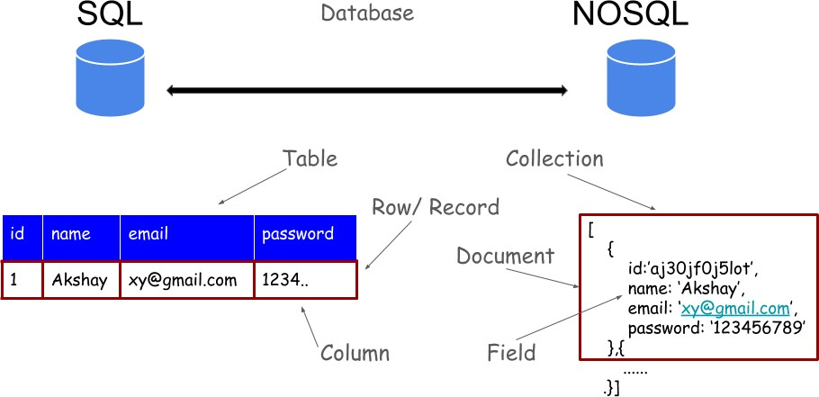

SQL | MongoDB
CREATE TABLE lju (  id MEDIUMINT NOT NULL AUTO_INCREMENT,  user_id Varchar(20), age Number,  status char(1), PRIMARY KEY (id)  ) | db.createCollection ( "lju”)  creates collection no need to define schema
ALTER TABLE lju ADD join_date DATETIME | db.lju.updateMany(  { },  { $set: { join_date: new Date() } }  )  Note:  new Date().toLocaleDateString()-The toLocaleDateString() method returns the date (not the time) of a date object as a string, using locale conventions.
ALTER TABLE lju DROP COLUMN  join_date | db.lju.updateMany(  { },  { $unset: { "join_date": "" } }  )
DROP TABLE lju | db.lju.drop()
INSERT INTO lju (name, age, status)  VALUES (“Test”, 45, "A") | db.lju.insertOne(  { name: “Test”, age: 18, status: "A" })
SELECT *FROM lju | db.lju.find()
SELECT id, name FROM lju | db.lju.find( { }, { name:1 } )
SELECT name, status FROM lju | db.lju.find( { }, { name:1,status:1,_id: 0 } )
SELECT * FROM lju WHERE status = "A" | db.lju.find( { status: "A" } )
SELECT name FROM lju WHERE status = "A" | db.lju.find( { status: "A" }, { name: 1,_id: 0 } )
SELECT * FROM lju WHERE status  != "A" | db.lju.find( { status: { $ne: "A" } } )
SELECT * FROM lju  WHERE status = "A" AND age = 50 | db.lju.find({status:”A”,age:50})  or  db.lju.find(  { $and: [ { status: "A" } , { age: 50 } ] }  )
SELECT * FROM lju WHERE status = "A" OR age = 30 | db.lju.find(  { $or: [ { status: "A" } , { age: 30 } ] }  )
SELECT * FROM lju WHERE age > 25 | db.lju.find(  { age: { $gt: 25 } }  )
SELECT * FROM lju WHERE age <= 25 | db.lju.find(  { age: { $lte: 25 } }  )
SELECT * FROM lju  WHERE age > 25 AND age<= 50 | db.lju.find(  { age: { $gt: 25, $lte: 50 } }  )
SELECT * FROM lju  WHERE name like "%abc%" | db.lju.find( { name: {$regex: /abc/ }} )
SELECT * FROM lju  WHERE name like "abc%" | db.lju.find( { name: /^abc/ } )  or  db.lju.find( { name: { $regex: /^abc/ } } )
SELECT * from lju where name=”abc” and age=20 | db.lju.find({name:"abc",age:20})
SELECT * FROM lju  WHERE status = "A" ORDER BY age ASC | db.lju.find( { status: "A" } ).sort({ age: 1 })
SELECT * FROM lju  WHERE status = "A" ORDER BY age DESC | db.lju.find( { status: "A" } ). sort( { age: -1  } )
SELECT COUNT(*) FROM lju | db.lju. count()  or  db. lju. find(). count()
SELECT COUNT(*) FROM lju  WHERE age > 30 | db.lju.count( { age: { $gt: 30 } } ) or  db.lju.find( { age: { $gt: 30 } } ).count()
SELECT * FROM lju LIMIT 1 | db.lju.findOne() or  db.lju.find().limit(1)
SELECT * FROM lju LIMIT 2 OFFSET 3; | db.lju.find().limit(2).skip(3)
EXPLAIN SELECT *  FROM lju WHERE status = "A" | db.lju. find( { status: "A" } ).explain()
UPDATE lju SET status = "C"  WHERE age > 25 | db.lju.updateMany( { age: { $gt: 25 } }, { $set: {  status: "C" } } )
UPDATE lju SET age = age + 3  WHERE status = "A" | db.lju.updateMany( { status: "A" } , { $inc: {  age: 3 }
DELETE FROM lju WHERE status =  "D" | db.lju.deleteMany( { status: "D" } )
DELETE FROM lju | db.lju.deleteMany( { } )
SELECT *  FROM lju  WHERE name NOT IN ('aaa','abc','bbb'); | db.lju.find( { name: { $nin: [ ‘aaa’,’abc’,’bbb’ ] } } )
SELECT name  FROM lju  WHERE age IN (20,23,33); | db.lju.find( { age: { $in: [ 20, 23, 33 ] } },{name:1,_id:0} )

Example
Question | SQL Query
1. Display students whose city is Ahmedabad and whose age is between 18 and 22. | SELECT * FROM student WHERE city='Ahmedabad' AND age BETWEEN 18 AND 22;
2. Display students whose marks are greater than 80 and whose status is 'A'. | SELECT * FROM student WHERE marks>80 AND status='A';
3. Display students whose city is Ahmedabad or Surat. | SELECT * FROM student WHERE city='Ahmedabad' OR city='Surat';
4. Display only the name and marks of students whose status is 'A'. | SELECT name, marks FROM student WHERE status='A';
5. Display students whose city is Ahmedabad or Rajkot and whose marks are greater than 75. | SELECT * FROM student WHERE (city='Ahmedabad' OR city='Rajkot') AND marks>75;
6. Display students whose age is greater than or equal to 20 and whose status is not 'B'. | SELECT * FROM student WHERE age>=20 AND status<>'B';
7. Display only the name and city of students whose marks are between 60 and 80 and whose status is 'A'. | SELECT name, city FROM student WHERE marks BETWEEN 60 AND 80 AND status='A';
8. Display students whose city is not Ahmedabad. | SELECT * FROM student WHERE city<>'Ahmedabad';
9. Display students whose age is 18, 20, or 22 and whose marks are greater than 75. | SELECT * FROM student WHERE age IN (18,20,22) AND marks>75;
10. Display students whose city is Ahmedabad or Surat and whose status is 'A', ordered by marks in descending order. | SELECT * FROM student WHERE (city='Ahmedabad' OR city='Surat') AND status='A' ORDER BY marks DESC;

